

**Maverick Dresses**

**Documentation**

|  |  |
| --- | --- |
| **Authors** | **C2402L – Group 4** |
| **Student1552157 – Do Duc Trung**  **Student1557859 – Nguyen Quoc Loc**  **Student1546550 – Nguyen Quang Nam**  **Student1552797 – Hoang Cong Dinh** |
| **Date** | **08-Jan-2025** |
| **Instructor** | **Tien Luc Van** |

Hanoi, 08 January 2025

## Index

Contents

1. Problem Definition 3

**1.1.** **Problem Abstraction** 3

***1.2.*** ***The Current System*** 3

***1.3.*** ***The Proposed System*** 4

2. Customer Requirements Specification 5

**2.1.**  **Users of the System** 5

**2.2**  ***System Functions*** 5

**2.2.2 Login** 7

**2.2.3 Home** 8

**2.2.4 Shop Categories** 9

**2.2.5 Product Detail Page** 10

**2.2.6 Shopping cart** 11

**2.2.8 Store Address** 13

**2.3 Admin** 14

**2.3.1 Dashboad** 14

**2.3.2 Product** 15

**2.3.3 User** 16

**2.3.4 Order** 17

3. System designs 18

**3.1.**  **Database Design** 18

**3.2**  **Site map** 19

**3.3**  **Sistem functions design** 20

**3.3.1 Resgistration** 20

**3.3.2 Login** 21

**3.3.3 Checkout** 22

4. Task sheet 23

5. Validation Checklists 24

1. **Problem Definition**
   1. **Problem Abstraction**

In today's era of industrialization and modernization, e-commerce platforms are increasingly developing to meet customers' online shopping needs. Maverick Dresses is a leading school uniform sales website, providing customers with complete information about high-quality male and female uniform products. The website is a place to shop for familiar uniform models for all schools easily and quickly.

The Maverick Dresses project was born from many different sources. One of the main reasons is that in the current era of internet development and industry 4.0, online shopping is becoming a current and future trend. Especially in school life, uniforms are an indispensable part. With a team of experienced experts, Maverick Dresses always brings creative designs, high-quality fabrics and ensures the right form for each student. The Maverick Dresses website was created to meet the needs of online uniform shopping in today's life. Our goal is to bring comfort, convenience and speed to school uniform shopping through online shopping.

* 1. ***The Current System***

Our website system includes navigation bars for categories: Logo, Search Bar and Shopping Cart, along with navigation bars that categorize products including Men's Uniforms, Women's Uniforms, New Collections, Accessories, School Uniforms and Store Address, helping customers shop and pay quickly and conveniently. The Logo section, which is the most special component of the website, will be provided to customers on the home page when clicked. The category products allow customers to quickly and conveniently select products in the product category they have chosen, helping to find the right outfits. The category product next to it is the Store Address section, providing customers with our contact information and Google Map address, so they know how and where to visit. The login section allows Maverick Dress's management to log in to manage the website and update products and information quickly. The search bar helps customers find relevant information by entering details, thereby reducing the time spent on product selection. The Shopping Cart section is where customers can review the products they have selected when adding to the cart.

Just below the navigation bar are the latest products on the website from different categories that are prominently displayed. Scrolling down are banners about special promotions for products. The product categories are displayed with high resolution images, along with price information and customer reviews. These products can be quickly added to the cart with the "add to cart" button. In addition, clicking on a product will display the detailed information page about that product, helping customers easily grasp the information before making a purchase decision.

Overall, our website provides a quick and convenient online shopping address for customers. Shopping for school uniforms has become fun and caters to the needs of every school with innovative designs, good quality and suitable looks.

* 1. ***The Proposed System***

The new system we are building will be a comprehensive online platform for the Maverick Dress website, providing a convenient shopping experience for customers. Here are the main functions of the system:

A. Products: Product categories - this will be where users search for products. The title bar displays the product categories available on the web, including:

• Shirts

• Dresses

• Long dresses

• P.T. T-shirts

• P.T. shorts

• P.T. track pants

• Belts

• Ties

• Logos

• Socks

b. Search bar: When users select a category, the products of that category will be displayed below the title bar. If users want to select a specific product, they can enter the product-related information in the search bar and that product will be displayed directly.

c. Store Address (Contact): You can see it at the bottom of the website, when you click on it, it will show you the way to the store.

d. Shopping Cart: This category allows users to check the products in the shopping cart to proceed to checkout or add/delete products.

f. Checkout: This category allows customers to review and confirm their order before completing the payment. The checkout process includes entering shipping information, choosing a payment method and reviewing the order before completing the transaction.

1. **Customer Requirements Specification**
   1. **Users of the System**

-**Customer**: purchases school uniform.

-**Admin**: Manages the website and product listings.

-**Guest**: Browse the website without logging in.

**The usages of the website to the clients:**

+) Browse products: explore a wide range of products with categories and filters.

+) View product details: access detailed product information, prices and reviews.

+) Manage account: create/manage account, update information

+) Shopping cart: add/update/delete items

+) Checkout process: secure payment with COD payment method and review order.

+) Customer reviews and ratings: leave and read product reviews and ratings.

**2.2 *System Functions***

**2.2.1 Sign up**

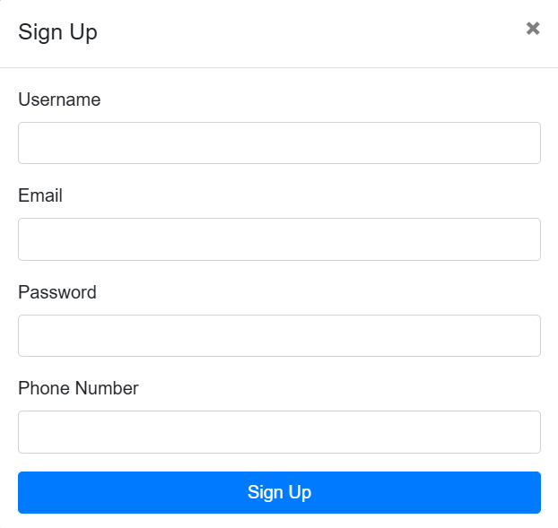

* Display Sign up interface
* Performs data validation in cells
* The email need to be in the correct format
* Click the “Sign up” button to register. If the above requirements are wrong , an error message will be displayed.

**2.2.2 Login**

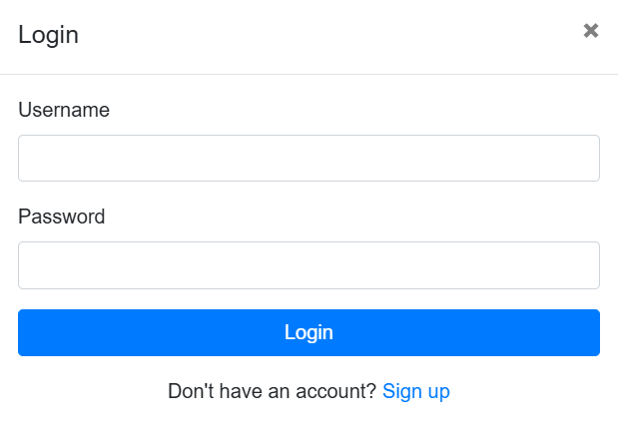

* Display the login interface
* Users will enter the information including Username and Password
* Click the “Login” button to login. If the above requirements are wrong , an error message will be displayed.
* If you don’t have an account yet, then click on “Sign up”, the system will turn into Sign up interface

**2.2.3 Home**

**2.2.4 Shop Categories**

**2.2.5 Product Detail Page**

**2.2.6 Shopping cart**

* + 1. **Checkout**

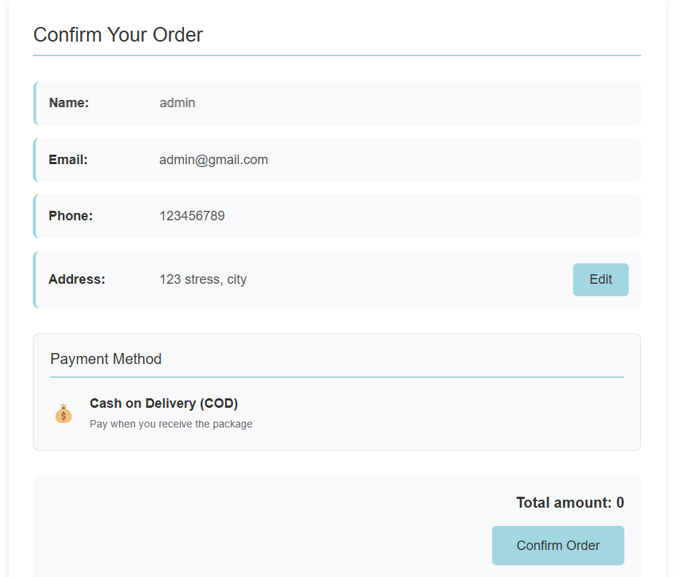

* The checkout interface shows us information about Name, Email, Phone, Address, Payment Method and Total amount.
* When you click Confirm Order, the order will be confirmed.

**2.2.8 Store Address**

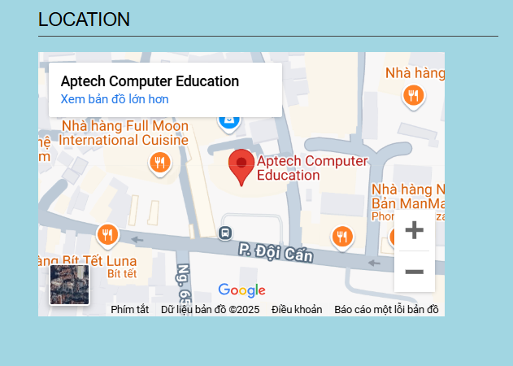

By scrolling down the footer, you can see the store address, clicking on it will give you directions to the store location.

**2.3 Admin**

**2.3.1 Dashboad**

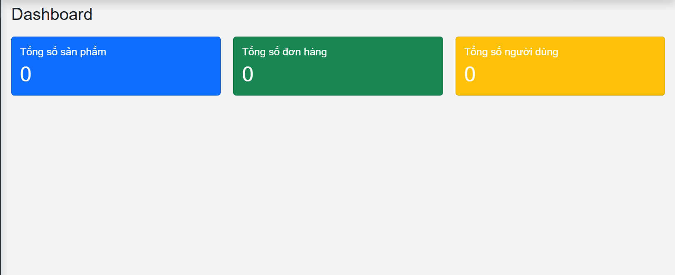

The web gives us an overview of the system:

- Total products (blue)

- Total orders (green)

- Total users (yellow)

**2.3.2 Product**

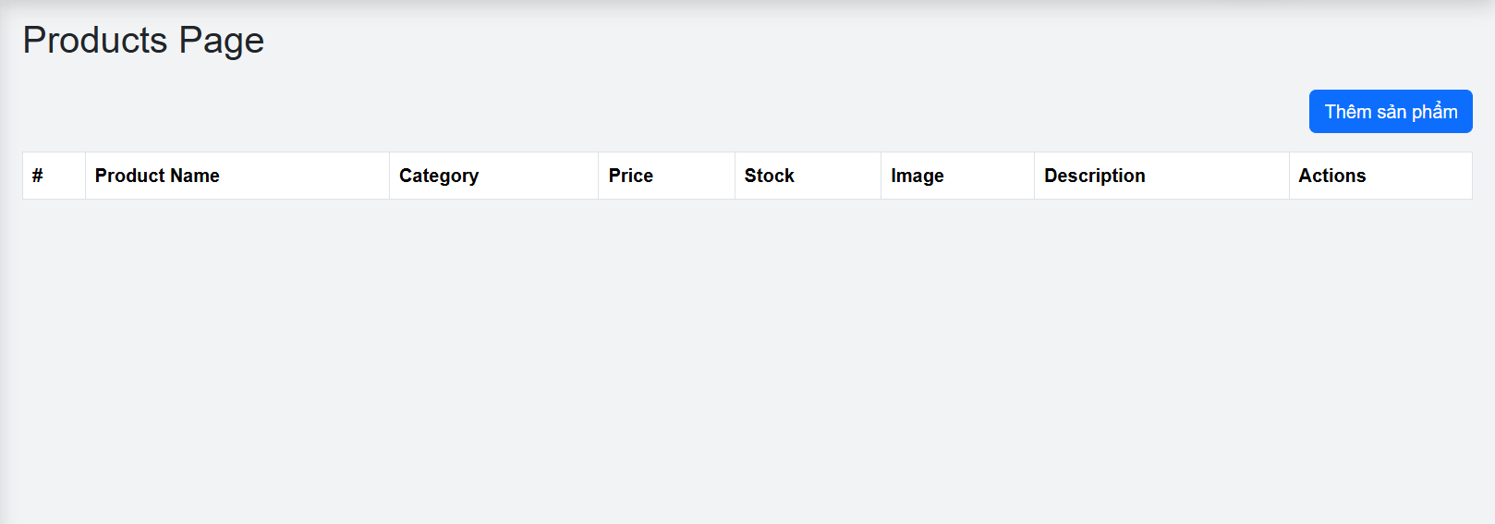

This Product interface shows:

- Product Name

- Category

- Price

- Stock

- Image

- Description

- Actions

The top right corner has a blue button with the content Add Product, used to add a new product.

**2.3.3 User**

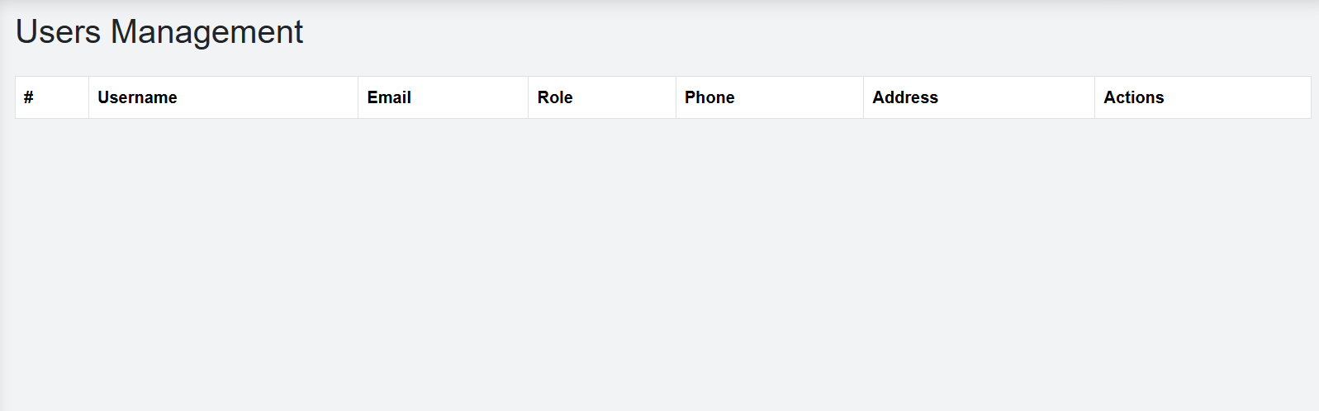

This User interface shows:

- Username

- Email

- Role

- Phone

- Address

- Actions

**2.3.4 Order**

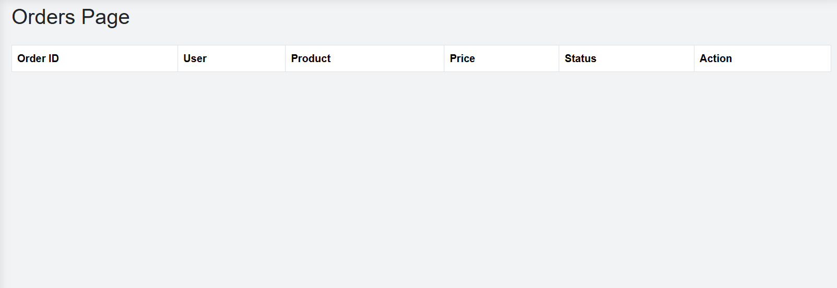

This Order interface shows:

- Order ID

- User

- Product

- Price

- Status

- Action

This interface is designed for managing orders, tracking details, and performing status-related actions or editing orders. The minimalist design makes it easy to use and focuses on the key data

1. **System designs**

**3.1. Database Design**

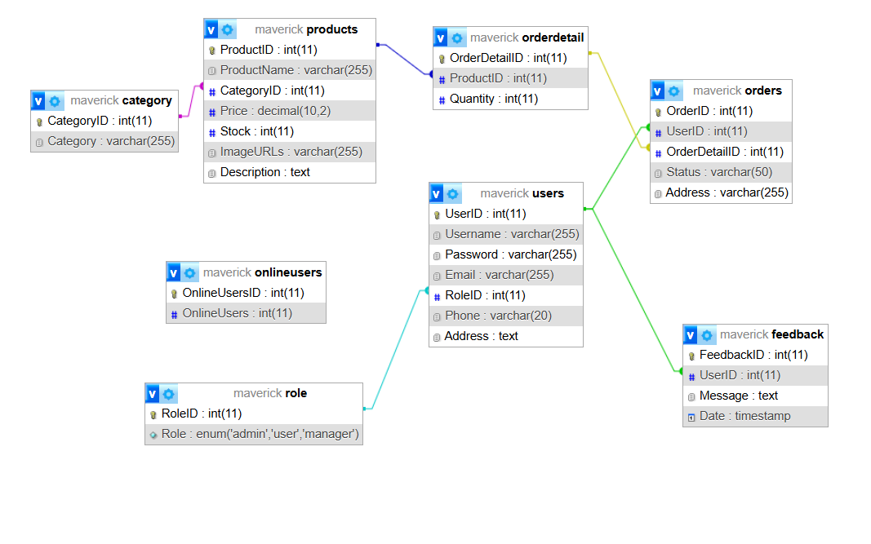

**3.2 Site map**

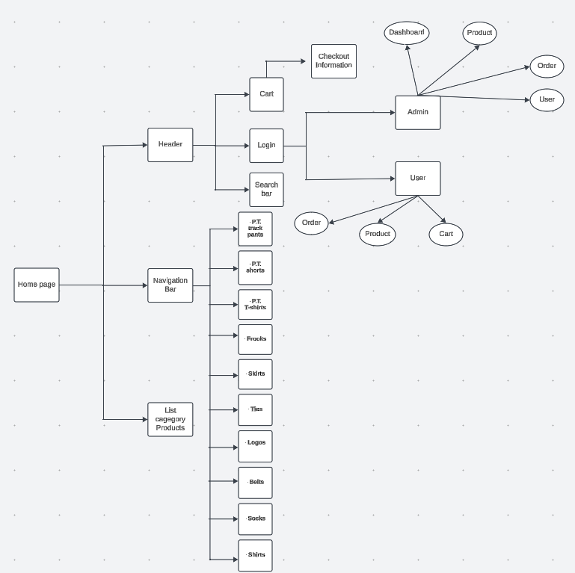

**3.3 Sistem functions design**

**3.3.1 Resgistration**

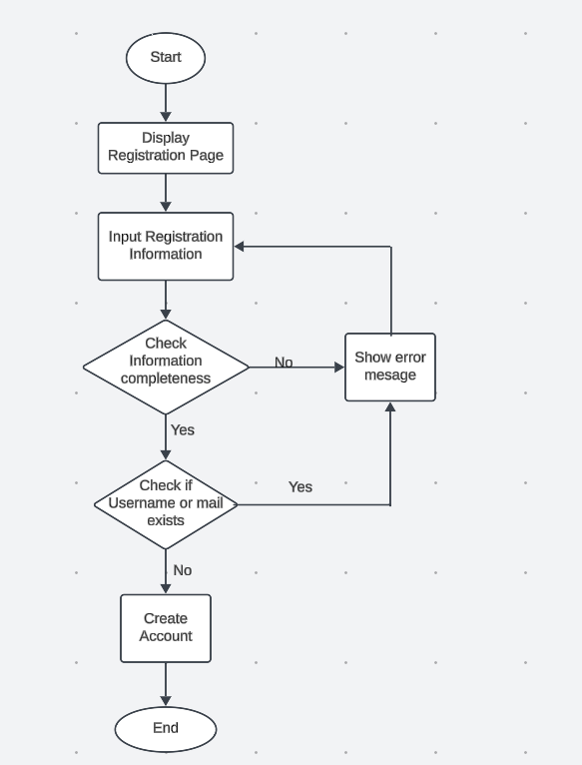

**3.3.2 Login**

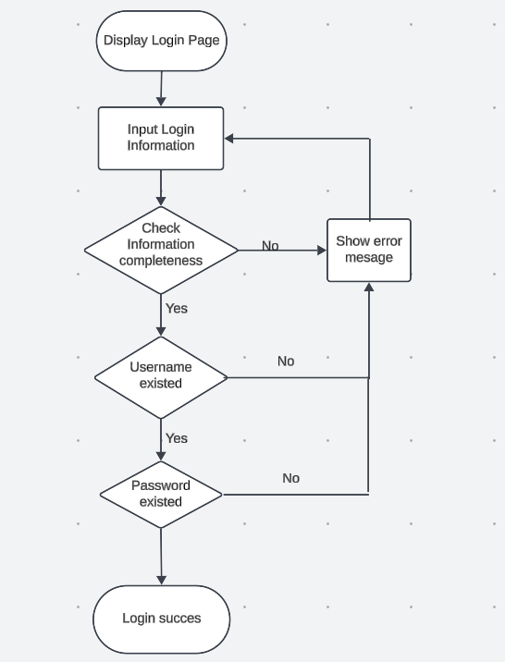

**3.3.3 Checkout**

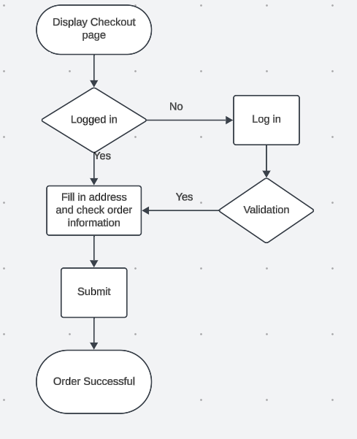

**4****. Task sheet**

**5. Validation Checklists**